Phase 3: Project Design Phase Document
Project Title: Import Data using transform maps (spreadsheets).

1. Architecture & Data Flow
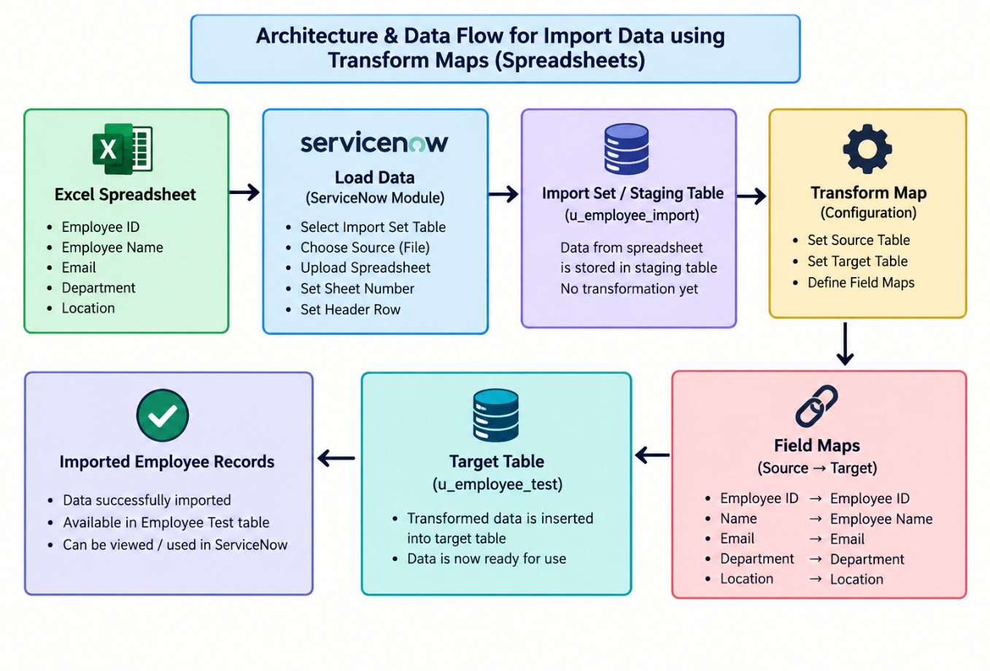

2. Component Design & Screenshots Checklist
- 1: Employee Import Table Details (System Definition -> Tables)
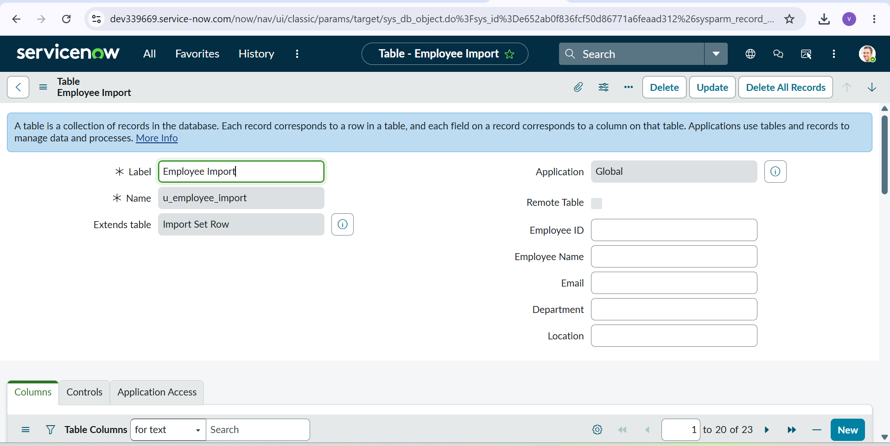

- 2: Employee Import Fields List

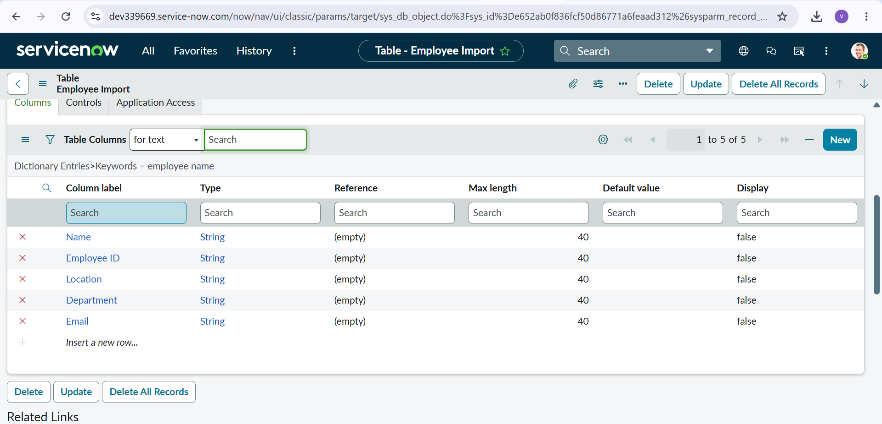

- 3: Transform Map Creation (System Import Sets -> Transform Maps -> New)
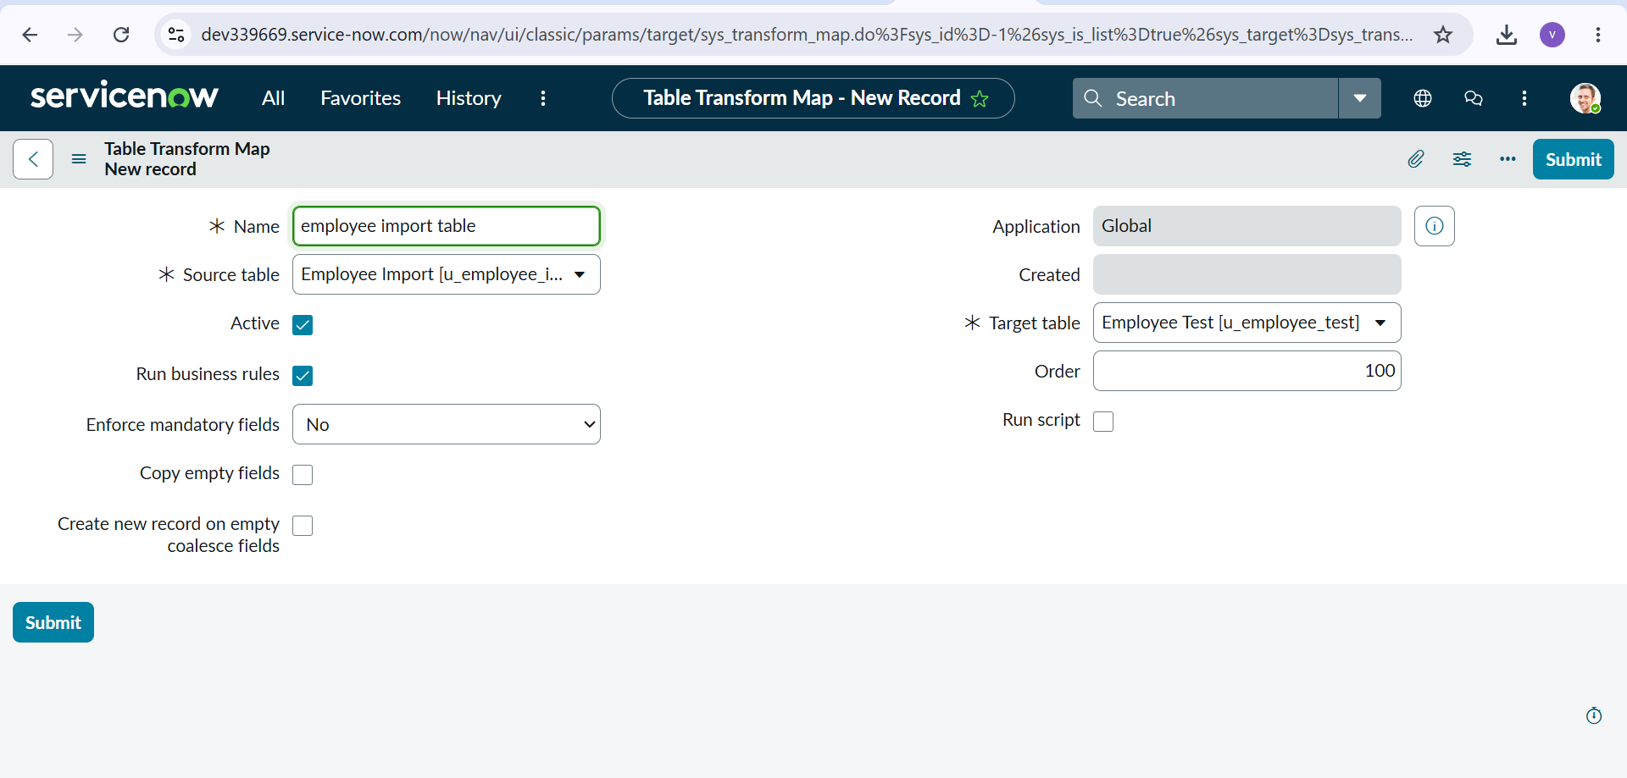

- 4: Transform Map Configuration Details
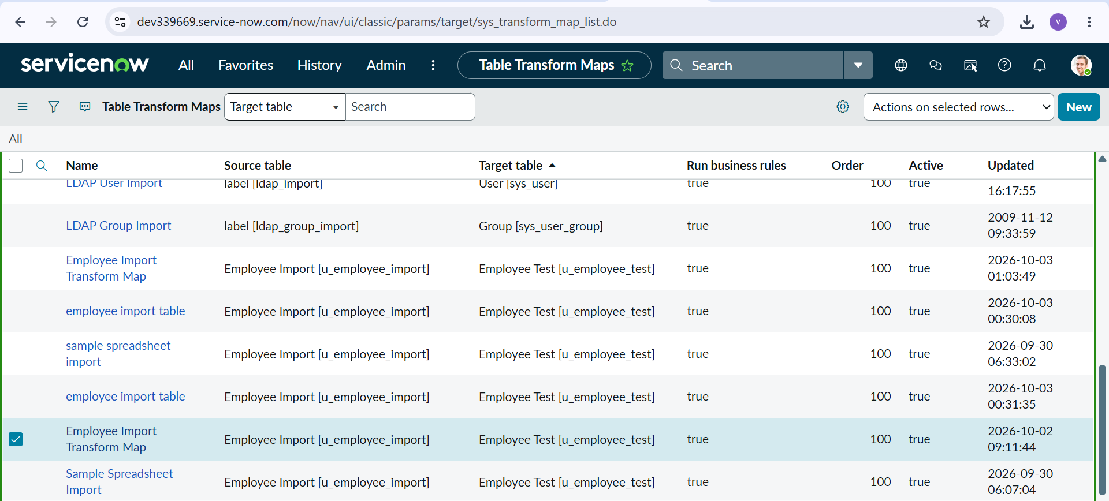

- 5: Field Maps Mapping Verification
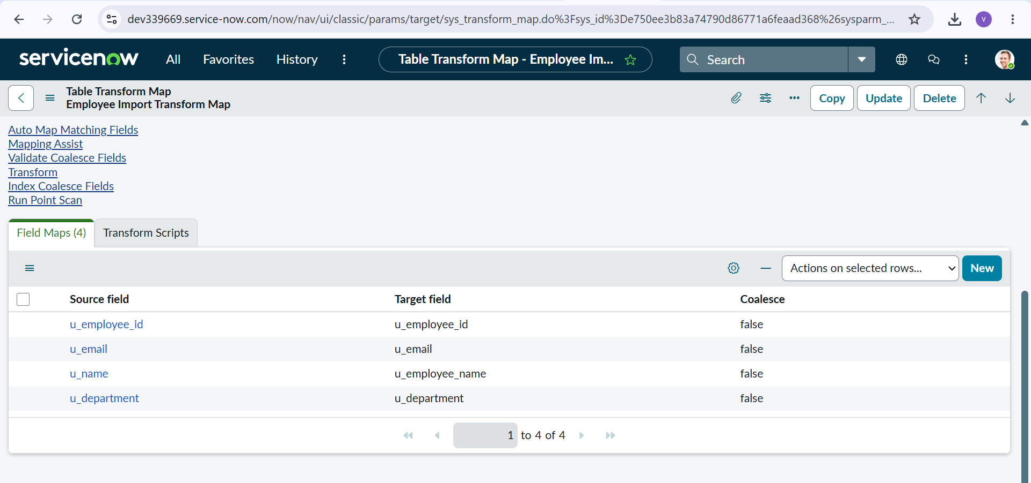

3. Field Mapping Architecture
- u_employee_id -> u_employee_id (Coalesce = True)

- u_employee_name -> u_employee_name (Coalesce = False)
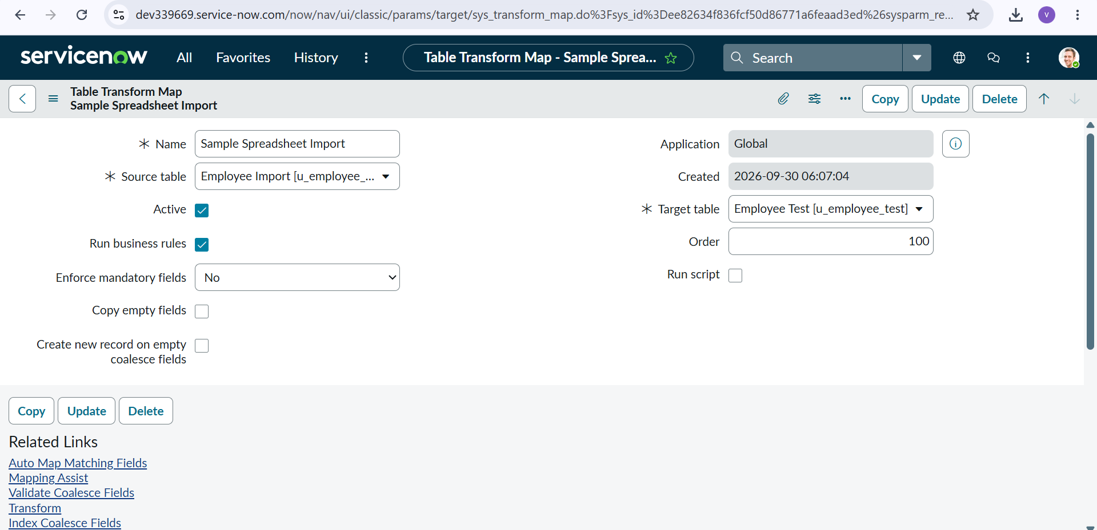

- u_email -> u_email (Coalesce = False)
- u_department -> u_department (Coalesce = False)
- u_location -> u_location (Coalesce = False)Excel File (.xlsx) -> Load Data -> Import Set Table (u_employee_import) -> Transform Map (Sample Spreadsheet Import) -> Field Mapping Verification -> Target Table (u_employee_test)

